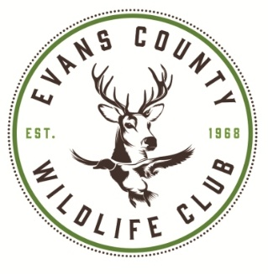
2026 Claxton Rattlesnake & Wildlife Festival Parade Route
Saturday, March 14, 2026
Parade Route:
From the intersection of Clark Street and Hwy 280 (Evans County Public Library), turn left (East) onto Highway 280 /Main Street; travel 0.7 miles.

Turn left (North) onto Hwy 301 at the Hwy 280/Hwy 301 Intersection; travel 0.7 miles.

Parade ends at the Claxton Square/Food Fresh Shopping Center.

Total Distance: 1.4 miles
